REMOTE INFRASTRUCTURE MANAGEMENT (DCE 204)
DEFINITION
Monitoring and managing all elements of enterprise infrastructure and resolving any issues from remote locations.
Enabling continuous availability - onsite repairs and maintenance are required only in cases of hardware failure.
Data centre, networks,email, devices,storage, ERP,OS,security,servers, support,database,applications,services.- with ability to perform remedial actions to enable continuous availability. On-site repair is done only when H/W fails.
A well planned RIM strategy can lead to cost saving of 25%-50% in an organization’s spend in IT infrastructure.
RIM used across banking,financial services, healthcare, telecommunication, ecommerce, transportation,etc.
BENEFIT
Centralized IT infrastructure management offers greater coordination and ease of maintenance and helps make IT an enabler of innovation. Benefits include cost savings, improved availability, reduced risk, and increased productivity, flexibility, and efficiency.
proactive real time monitoring 24/7
significant cost saving
minimise downtime , enhanced productivity
risk reduction, higher level of service
greater ROI , consolidated provisioning and management.
SERVICES
desktop management, Database Management, network management ,IT Asset management, migration services server support and management storage management application management remote staff augmentation (it is the practice of hiring skilled software developers and it professionals from a third party, depending on the project need for business goals it can be short term or contractual).
Remote IT infrastructure management utilizes a range of tools that enable IT teams to monitor, manage, and troubleshoot systems remotely. These tools fall into several categories:
Remote Monitoring and Management (RMM): Software that provides real-time monitoring of networks and systems, automates routine tasks, and manages patches and updates. Examples include SolarWinds, ConnectWise Automate, and Kaseya VSA.
Remote Access Tools: Allow IT staff to connect to and control a system from a remote location. Popular tools include TeamViewer, Remote Desktop Protocol (RDP), and AnyDesk.
Configuration Management Tools: Automate configuration and management of hardware and software. Puppet, Chef, and Ansible are widely used for their robust automation capabilities.
Network Management Tools: Monitor network traffic, manage routers and switches, and troubleshoot network issues. Cisco Network Assistant and NetFlow are examples of tools used for network management.
Security Management Tools: Essential for ensuring data integrity and security in remote management settings. They include firewalls, intrusion detection systems (IDS), and antivirus software.
NAGIOS
nagios is an open source it system monitoring tool. It was designed to run on the Linux operating system and can monitor devices running Linux, Windows and Unix OSes. Nagios software runs periodic checks on critical parameters of application, network and server resources. For example, Nagios can monitor memory use, disk use and microprocessor load, as well as the number of currently running processes and log files. Nagios also can monitor services such as Simple Mail Transfer Protocol (SMTP), Post Office Protocol 3, Hypertext Transfer Protocol (HTTP) and other common network protocols. Nagios initiates active checks, while passive checks come from external applications connected to the monitoring tool.
HOW NAGIOS WORK
Nagios' dashboard provides an overview of the critical parameters monitored on assets.
Based on the parameters and thresholds defined, Nagios can send out alerts if critical levels are reached. These notifications can be sent through email and text messages. An authorization system enables administrators to restrict access.
Nagios runs both agent-based and Agentless configurations. Independent agents are installed on any hardware or software system to collect data that is then reported back to the management server. Agentless monitoring uses existing protocols to emulate an agent. Both approaches can monitor file system use, OS metrics, service and process states. Examples of Nagios agents include Nagios Remote Data Processor (NRDP), Nagios Cross Platform Agent.
FEATURES
Monitoring of network services (SMTP, POP3, HTTP, NNTP, PING, etc.)
Monitoring of host resources (processor load, disk usage, etc.)
Simple plugin design that allows users to easily develop their own service checks
Parallelized service checks
Ability to define network host hierarchy using "parent" hosts, allowing detection of and distinction between hosts that are down and those that are unreachable
Contact notifications when service or host problems occur and get resolved (via email, pager, or user-defined method)
Ability to define event handlers to be run during service or host events for proactive problem resolution
Automatic log file rotation
Support for implementing redundant monitoring hosts
Optional web interface for viewing current network status, notification and problem history, log file, etc.

Nagios Core
The service that was originally known as Nagios is now referred to as Nagios Core. Core is freely available as an open source monitoring software for IT systems, networks and infrastructure. Core contains a wide array of infrastructure monitoring through allowing plugins to extend its monitoring capabilities. It is the base for paid Nagios monitoring systems.
Nagios Core has an optional web interface, which displays network status, notifications and log files. Core can notify its user when there are server or host issues. Additionally, Core can monitor network services such as SMTP, HTTP and Ping.
Nagios XI
Nagios XI is an extended interface of Nagios Core, intended as the enterprise-level version of the monitoring tool. XI acts as monitoring software, configuration manager and toolkit. While Nagios Core is free, XI must be purchased from Nagios Enterprises. Atop the same features as Core, XI adds preconfigured virtual machines (VMs), a web configuration user interface, performance graphing, a mobile application, dashboards, scheduled reporting and technical support through email.
Web-Based Configuration provides advanced configuration features
Monitoring Wizards make it easy to monitor new devices, applications, and services
Customizable Dashboards allow for per-user customization
Integrated Performance Graphs provide trending and capacity planning information
Advanced Reports provide data insight and exporting capabilities
Data Visualizations enable powerful analysis of patterns and problems
Nagios Core Import functionality makes it easy to migrate from Nagios Core

Nagios XI monitors IT infrastructure components such as applications, OSes, networks and system metrics. Plugins are supported for these infrastructure components to expand on XI's monitoring capabilities.
Nagios commercial extensions
Nagios Log Server is a log monitoring and management tool that enables an organization to view, sort and configure logs from its IT infrastructure, including Windows event logs. Log Server can analyze, collect and store logged data based on custom and preassigned specifications. Administrators can set alerts to notify Log Server users when there is a potential threat or malfunction on a monitored asset. For example, an alert goes out to the Microsoft Exchange administrator when there are three failed login attempts to Exchange Server, meaning there could be an unwarranted person trying to guess the password to the system.
Nagios Network Analyzer tracks network traffic and bandwidth use. Network Analyzer can resolve network outages, abnormalities and security threats. Features include automated security alerts, customizable application monitoring, integration with Nagios IX and a bandwidth use calculator.
Nagios Fusion is an aggregation service for Nagios Core and Nagios XI servers that shows multiple systems in one view. Fusion condenses network management by centralizing features and data from Nagios XI and Core in one location, creating a granular view of a network infrastructure. With Fusion, administrators can specify which XI and Core servers are displayed and manage which users are allowed to view those servers. Additionally, Fusion users can log into any managed server and use cached or live data to configure charts and other graphics to appear on dashboards.
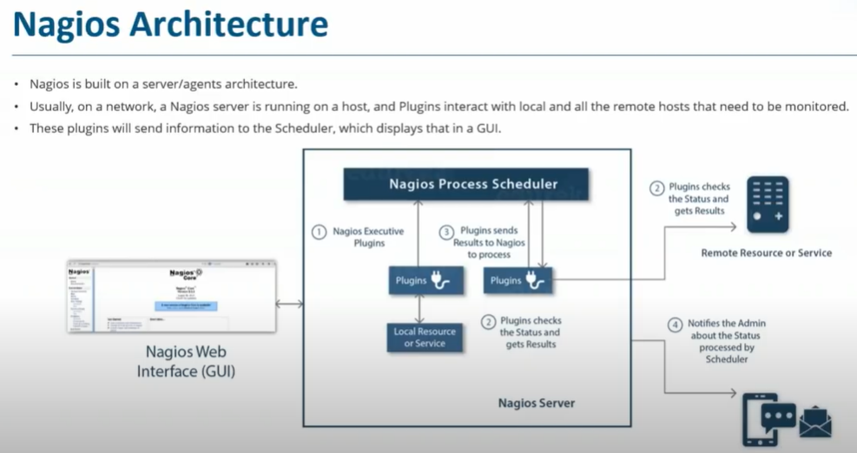
HOW TO INSTALL NAGIOS
Installation on Vmware
Installation on Hyper V
Short for Secure Shell and Secure Sockets Layer, respectively, SSH and SSL share many similarities. For example, they both help create a secure connection on the web. However, there are a handful of differences between the two that are important to understand so you can ensure that you’re using these features properly.
In this post, we’ll introduce you to both SSH and SSL, explaining what each one is and what they’re used for. Then we’ll take a deeper dive to discuss some of the key differences between the two. Let’s get started!
An introduction to SSL
As we mentioned earlier, SSL is short for “Secure Sockets Layer”. It is a security protocol that helps safeguard the protection between web browsers and servers by encrypting the data that is transmitted between the two.
As a WordPress user, you may be at least somewhat familiar with the term from having to install an SSL certificate on your site. SSL is needed in order to enable HTTPS browsing:
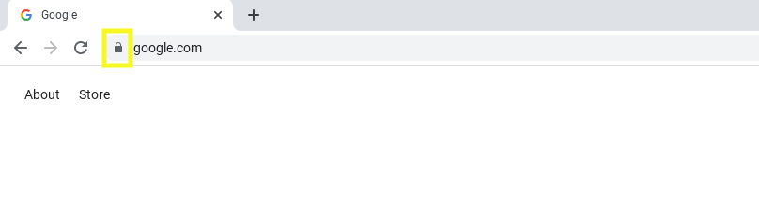
It’s important to note that, although many people still refer to it as SSL, this term is technically the outdated version of Transport Layer Security (TLS) protocol. In a nutshell, SSL 2.0 and SSL 3.0 are now obsolete and have been upgraded to TLS 1.2 and 1.3. While there are some differences, they basically function the same way and serve the same purpose. Thus, for this article we’ll refer to it as SSL.
SSL helps encrypt your data while it’s in transit, to prevent malicious actors from intercepting it and executing Man-in-the-Middle (MiTM) attacks. The SSL protocol is applied to servers via SSL certificates.
SSL serves two main purposes: data encryption and authentication. Data encryption protects sensitive information such as credit card information, passwords, and social security numbers. Meanwhile, authentication is used to verify the server and browser identification.
An introduction to SSH
SSH stands for Secure Shell. It is a cryptographic protocol that enables a secure connection to a server. Its purpose is to help protect your site files and data from being compromised when managing them via a remote connection. Basically, it helps to safeguard your server.
Chances are that when you’re accessing your website’s server, it’s done via SSH. This is instead of, for example, accessing the original server located at your hosting provider company. SSH helps ensure that when you’re performing tasks such as adding new files for plugins and themes on your WordPress site, hackers won’t be able intercept the data.
However, you may not necessarily require SSH access. For example, one of the reasons many users opt for managed WordPress hosting is so that they don’t have to handle the technical tasks themselves. However, if you’re more hands-on, you may wish to obtain this level of control. If that’s the case, it’s important to choose a host that offers SSH access, as not all do:

The process of creating an encrypted connection is done via what’s known as SSH tunneling. To create the tunnel, authentication is needed using a set of cryptographic public and private keys, or a username and password.
SSH vs SSL: Understanding the key differences
Now that we understand a little bit more about each of these encryption protocols, let’s take a look at how they differ. Below are three key differences between SSH vs SSL:
They use different ports. SSH works on port 22. SSL works on post 443.
Different forms of authentication are used. SSH has a username and password authentication system, whereas SSL doesn’t. SSL uses digital certificates and public key infrastructure, and authentication only happens on the server-side. Meanwhile, SSH uses a three-step process: server verification, session key generation, and client authentication.
They are used for different types of encryption. SSH is used to encrypt communication happening between two computers or systems online. It enables users to run commands remotely. On the other hand, SSL is used to encrypt communication between browsers and servers – or, in other words, between websites and visitors.
Of course, there are additional differences that distinguish the two. However, the aforementioned three are the most important ones to be aware of.
How to get SSH and SSL for your WordPress site
By now, you likely understand the main points regarding SSH vs SSL. However, you may not be sure how to actually obtain the two for your WordPress site.
Let’s start with SSH. As we mentioned earlier, the easiest way to acquire SSH access is to choose a hosting provider that offers that level of control with its package.
The process for using SSH varies by host. For example, sometimes you have to request for it to be enabled. Other times, it may be offered as a one-click feature. If you’re a more experienced user or a developer, you may also be able to use it with a system such as puTTY.
We recommend checking with your web host for further guidance. They’ll likely have specific instructions or documentation you can refer to.
Meanwhile, if you’re looking for an SSL certificate for your website, you have a couple of options. One is to obtain the certificate for free using a website such as Let’s Encrypt:

Here, you’ll be able to sign up for an SSL certificate and then install it on your website. You can also configure your WordPress site with SSL using a plugin such as Really Simple SSL.
However, a quicker and simpler approach is to just ask your hosting provider if they offer it. Most hosts will include a free SSL certificate with their hosting packages. They might also provide a one-click feature for you to enable it with your WordPress installation.
Conclusion
When you’re managing a WordPress site, it’s essential to ensure that you’re using secure methods to safeguard your data. This includes using encryption and authentication protocols so that your communication is protected from malicious actors. Both SSH and SSL help you do this, but differentiating between the two can be challenging.
As we discussed in this article, there are three key differences between SSH vs SSL:
SSL works on port 443, while SSH works on port 22.
SSH uses a username/password authentication system, while SSL uses a digital certificate.
SSH encrypts remote communication between computers, while SSL establishes a secure connection between servers and browsers.
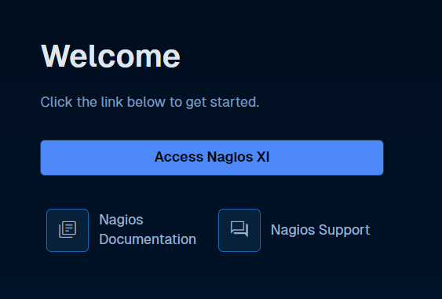
NAGIOS PLUGIN
Plugins are compiled executables or scripts (Perl scripts, shell scripts, Python, PHP, Ruby, etc.) that can be run from a command line to check the status or a host or service. Nagios Core uses the results from plugins to determine the current status of hosts and services on your network.
Nagios Core will execute a plugin whenever there is a need to check the status of a service or host. The plugin does something (notice the very general term) to perform the check and then simply returns the results to Nagios Core. Nagios Core will process the results that it receives from the plugin and take any necessary actions (running event handlers, sending out notifications, etc).
Plugins As An Abstraction Layer
Plugins act as an abstraction layer between the monitoring logic present in the Nagios Core daemon and the actual services and hosts that are being monitored.
The upside of this type of plugin architecture is that you can monitor just about anything you can think of. If you can automate the process of checking something, you can monitor it with Nagios Core. There are already a lot of plugins that have been created in order to monitor basic resources such as processor load, disk usage, ping rates, etc. If you want to monitor something else, take a look at the documentation on writing plugins and roll your own.
The downside to this type of plugin architecture is the fact that Nagios Core has absolutely no idea what it is that you're monitoring. You could be monitoring network traffic statistics, data error rates, room temperate, CPU voltage, fan speed, processor load, disk space, or the ability of your super-fantastic toaster to properly brown your bread in the morning. Nagios Core doesn't understand the specifics of what's being monitored - it just tracks changes in the state of those resources. Only the plugins themselves know exactly what they're monitoring and how to perform the actual checks.

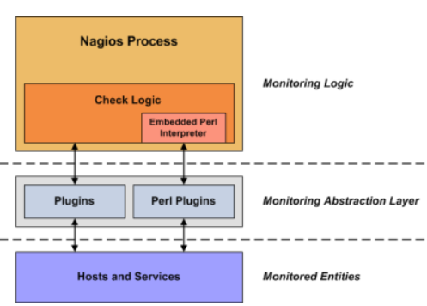
There are plugins currently available to monitor many different kinds of devices and services, including:
HTTP, POP3, IMAP, FTP, SSH, DHCP
CPU Load, Disk Usage, Memory Usage, Current Users
Unix/Linux, Windows, and Netware Servers
Routers and Switches ,etc.
Plugin Overview
Scripts and executables must do two things (at a minimum) in order to function as Nagios plugins:
Exit with one of several possible return values
Return at least one line of text output to STDOUT
Plugin could check the status of a TCP port, run a database query, check disk free space, or do whatever else it needs to check something. The details will depend on what needs to be checked.
Plugin Return Code
Nagios determines the status of a host or service by evaluating the return code from plugins. The following tables shows a list of valid return codes, along with their corresponding service or host states.
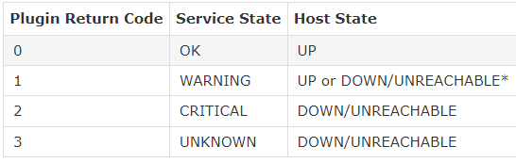
Plugin Output Examples
Let's see some examples of possible plugin output...
Case 1: One line of output (text only)
Assume we have a plugin that returns one line of output that looks like this:
DISK OK - free space: / 3326 MB (56%);
If this plugin was used to perform a service check, the entire line of output will be stored in the $SERVICEOUTPUT$ macro.
Case 2: One line of output (text and perfdata)
A plugin can return optional performance data for use by external applications. To do this, the performance data must be separated from the text output with a pipe (|) symbol like such:
DISK OK - free space: / 3326 MB (56%);
|
/=2643MB;5948;5958;0;5968
If this plugin was used to perform a service check, the
red

portion of output (left of the pipe separator) will be stored in the $SERVICEOUTPUT$ macro and the

orange

portion of output (right of the pipe separator) will be stored in the $SERVICEPERFDATA$ macro.

Case 3: Multiple lines of output (text and perfdata)
A plugin optionally return multiple lines of both text output and perfdata, like such:
DISK OK - free space: / 3326 MB (56%); | /=2643MB;5948;5958;0;5968
/ 15272 MB (77%);
/boot 68 MB (69%);
/home 69357 MB (27%);
/var/log 819 MB (84%); | /boot=68MB;88;93;0;98
/home=69357MB;253404;253409;0;253414
/var/log=818MB;970;975;0;980
If this plugin was used to perform a service check, the red portion of first line of output (left of the pipe separator) will be stored in the $SERVICEOUTPUT$ macro. The orange portions of the first and subsequent lines are concatenated (with spaces) are stored in the $SERVICEPERFDATA$ macro. The blue portions of the 2nd - 5th lines of output will be concatenated (with escaped newlines) and stored in $LONGSERVICEOUTPUT$ the macro.
The final contents of each macro are listed below:
Macro | Value
$SERVICEOUTPUT$ | DISK OK - free space: / 3326 MB (56%);
$SERVICEPERFDATA$ | /=2643MB;5948;5958;0;5968 /boot=68MB;88;93;0;98 /home=69357MB;253404;253409;0;253414 /var/log=818MB;970;975;0;980
$LONGSERVICEOUTPUT$ | / 15272 MB (77%);\n/boot 68 MB (69%);\n/var/log 819 MB (84%);

ACTIVE CHECK/MONITORING
Nagios is capable of monitoring hosts and services in two ways: actively and passively. Passive checks are described elsewhere, so we'll focus on active checks here. Active checks are the most common method for monitoring hosts and services. The main features of actives checks as as follows:
Active checks are initiated by the Nagios process
Active checks are run on a regularly scheduled basis
How Are Active Checks Performed?
Active checks are initiated by the check logic in the Nagios daemon. When Nagios needs to check the status of a host or service it will execute a plugin and pass it information about what needs to be checked. The plugin will then check the operational state of the host or service and report the results back to the Nagios daemon. Nagios will process the results of the host or service check and take appropriate action as necessary (e.g. send notifications, run event handlers, etc)
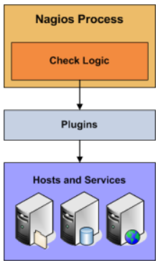
When Are Active Checks Executed?
Active check are executed:
At regular intervals, as defined by the check_interval and retry_interval options in your host and service definitions
On-demand as needed.
Regularly scheduled checks occur at intervals equaling either the check_interval or the retry_interval in your host or service definitions, depending on what type of state the host or service is in. If a host or service is in a HARD state, it will be actively checked at intervals equal to the check_interval option. If it is in a SOFT state, it will be checked at intervals equal to the retry_interval option.
STATE TYPES
he current state of monitored services and hosts is determined by two components:
The status of the service or host (i.e. OK, WARNING, UP, DOWN, etc.)
Tye type of state the service or host is in
There are two state types in Nagios - SOFT states and HARD states. These state types are a crucial part of the monitoring logic, as they are used to determine when event handlers are executed and when notifications are initially sent out.
This document describes the difference between SOFT and HARD states, how they occur, and what happens when they occur.
Service and Host Check Retries
In order to prevent false alarms from transient problems, Nagios allows you to define how many times a service or host should be (re)checked before it is considered to have a "real" problem. This is controlled by the max_check_attempts option in the host and service definitions. Understanding how hosts and services are (re)checked in order to determine if a real problem exists is important in understanding how state types work.
Soft States
Soft states occur in the following situations...
When a service or host check results in a non-OK or non-UP state and the service check has not yet been (re)checked the number of times specified by the max_check_attempts directive in the service or host definition. This is called a soft error.
When a service or host recovers from a soft error. This is considered a soft recovery.
The following things occur when hosts or services experience SOFT state changes:
The SOFT state is logged.
Event handlers are executed to handle the SOFT state.
SOFT states are only logged if you enabled the log_service_retries or log_host_retries options in your main configuration file.

Hard States
Hard states occur for hosts and services in the following situations:
When a host or service check results in a non-UP or non-OK state and it has been (re)checked the number of times specified by the max_check_attempts option in the host or service definition. This is a hard error state.
When a host or service transitions from one hard error state to another error state (e.g. WARNING to CRITICAL).
When a service check results in a non-OK state and its corresponding host is either DOWN or UNREACHABLE.
When a host or service recovers from a hard error state. This is considered to be a hard recovery.
When a passive host check is received. Passive host checks are treated as HARD unless the passive_host_checks_are_soft option is enabled.
The $HOSTSTATETYPE$ or $SERVICESTATETYPE$ macros will have a value of "HARD" when event handlers are executed, which allows your event handler scripts to know when they should take corrective action.
Example
Here's an example of how state types are determined, when state changes occur, and when event handlers and notifications are sent out. The table below shows consecutive checks of a service over time. The service has a max_check_attempts value of 3.
Time | Check # | State | State Type | State Change | Notes
0 | 1 | OK | HARD | No | Initial state of the service
1 | 1 | CRITICAL | SOFT | Yes | First detection of a non-OK state. Event handlers execute.
2 | 2 | WARNING | SOFT | Yes | Service continues to be in a non-OK state. Event handlers execute.
3 | 3 | CRITICAL | HARD | Yes | Max check attempts has been reached, so service goes into a HARD state. Event handlers execute and a problem notification is sent out. Check # is reset to 1 immediately after this happens.
4 | 3 | WARNING | HARD | Yes | Service changes to a HARD WARNING state. Event handlers execute and a problem notification is sent out.
5 | 3 | WARNING | HARD | No | Service stabilizes in a HARD problem state. Depending on what the notification interval for the service is, another notification might be sent out.
6 | 1 | OK | HARD | Yes | Service experiences a HARD recovery. Event handlers execute and a recovery notification is sent out.
7 | 1 | OK | HARD | No | Service is still OK.
8 | 1 | UNKNOWN | SOFT | Yes | Service is detected as changing to a SOFT non-OK state. Event handlers execute.
9 | 2 | OK | SOFT | Yes | Service experiences a SOFT recovery. Event handlers execute, but notification are not sent, as this wasn't a "real" problem. State type is set HARD and check # is reset to 1 immediately after this happens.
10 | 1 | OK | HARD | No | Service stabilizes in an OK state.

PASSIVE CHECK
In most cases you'll use Nagios to monitor your hosts and services using regularly scheduled active checks. Active checks can be used to "poll" a device or service for status information every so often. Nagios also supports a way to monitor hosts and services passively instead of actively. The key features of passive checks are as follows:
Passive checks are initiated and performed by external applications/processes
Passive check results are submitted to Nagios for processing
The major difference between active and passive checks is that active checks are initiated and performed by Nagios, while passive checks are performed by external applications.
Uses For Passive Checks
Passive checks are useful for monitoring services that are:
Asynchronous in nature and cannot be monitored effectively by polling their status on a regularly scheduled basis
Located behind a firewall and cannot be checked actively from the monitoring host
Examples of asynchronous services that lend themselves to being monitored passively include SNMP traps and security alerts. You never know how many (if any) traps or alerts you'll receive in a given time frame, so it's not feasible to just monitor their status every few minutes.
How Passive Checks Work
An external application checks the status of a host or service.
The external application writes the results of the check to the external command file.
The next time Nagios reads the external command file it will place the results of all passive checks into a queue for later processing. The same queue that is used for storing results from active checks is also used to store the results from passive checks.
Nagios will periodically execute a check result reaper event and scan the check result queue. Each service check result that is found in the queue is processed in the same manner - regardless of whether the check was active or passive. Nagios may send out notifications, log alerts, etc. depending on the check result information.
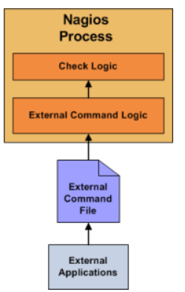
Enabling Passive Checks
In order to enable passive checks in Nagios, you'll need to do the following:
Set accept_passive_service_checks directive to 1.
Set the passive_checks_enabled directive in your host and service definitions to 1.
If you want to disable processing of passive checks on a global basis, set the accept_passive_service_checks directive to 0.
If you would like to disable passive checks for just a few hosts or services, use the passive_checks_enabled directive in the host and/or service definitions to do so.
Submitting Passive Service Check Results
External applications can submit passive service check results to Nagios by writing a PROCESS_SERVICE_CHECK_RESULT external command to the external command file.
The format of the command is as follows:
[<timestamp>] PROCESS_SERVICE_CHECK_RESULT;<host_name>;<svc_description>;<return_code>;<plugin_output>

timestamp is the time in time_t format (seconds since the UNIX epoch) that the service check was perfomed (or submitted). Please note the single space after the right bracket.
host_name is the short name of the host associated with the service in the service definition
svc_description is the description of the service as specified in the service definition
return_code is the return code of the check (0=OK, 1=WARNING, 2=CRITICAL, 3=UNKNOWN)
plugin_output is the text output of the service check (i.e. the plugin output)
Submitting Passive Host Check Results
<timestamp>] PROCESS_HOST_CHECK_RESULT;<host_name>;<host_status>;<plugin_output>
where...
timestamp is the time in time_t format (seconds since the UNIX epoch) that the host check was perfomed (or submitted). Please note the single space after the right bracket.
host_name is the short name of the host (as defined in the host definition)
host_status is the status of the host (0=UP, 1=DOWN, 2=UNREACHABLE)
plugin_output is the text output of the host check
Note: A service must be defined in Nagios before you can submit passive check results for it! Nagios will ignore all check results for services that had not been configured before it was last (re)started.
Note: Passive host checks are normally treated as HARD states, unless he passive_host_checks_are_soft option is enabled.
CONFIGURIATION WIZARD IN NAGIOS XI
Configuration wizards are addons to Nagios XI that make it easy for end-users to monitor new devices, services, and applications with Nagios XI. Wizards provide a user-friendly interface to what otherwise might be a complex task. They are especially useful for users who are new to Nagios XI, they create all the related monitoring configurations without needing to understand how Nagios XI works in the back-end.
Common Steps In Wizards: In the following screenshot you can see how the search field allows you to quickly find a wizard.
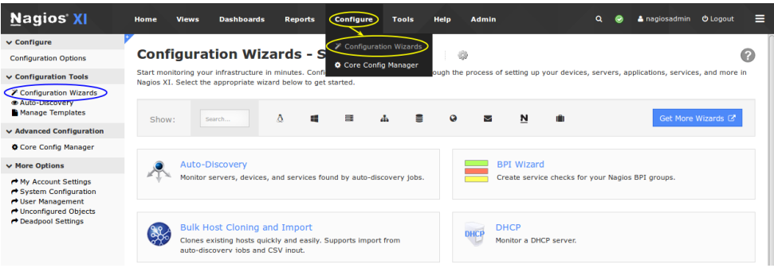
The options presented in Step 1 will be relative to the type of configuration wizard being run. In this example you will be asked to supply the address of the machine running the NRPE client and you will also have to select the Operating System. Click Next to progress to step 2.
The options presented in Step 2 will be relative to the type of configuration wizard being run. You will almost always be required to provide a Host Name. This name will be defined in the host_name directive of the host object that is created by the wizard.
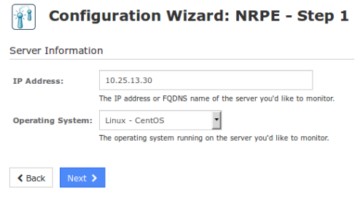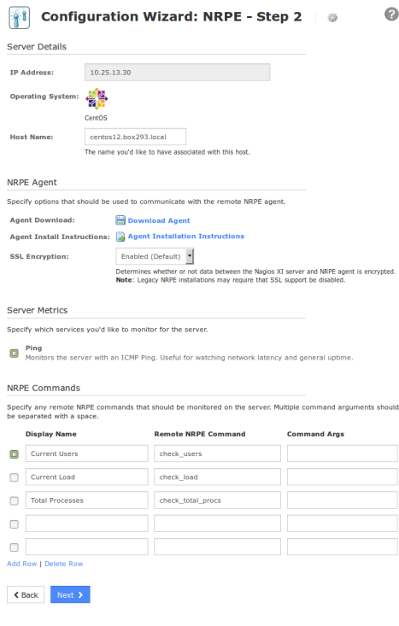

After making all of your required selections click the Next button to proceed to Step 3.
Step 3 provides the options for how often the device will be monitored (normally and when a problem is detected). These options will be defined in the check_interval, retry_interval and max_check_attempts directives of the host and service objects that are created by the wizard.
After making all of your required selections click the Next button to proceed to Step 4.
Step 4 provides the notification options for when a problem is detected. These options will be defined in the first_notification_delay, notification_interval, contacts and contact_groups directives of the host and service objects that are created by the wizard. After making all of your required selections click the Next button to proceed to Step 5.
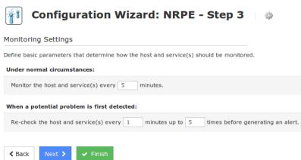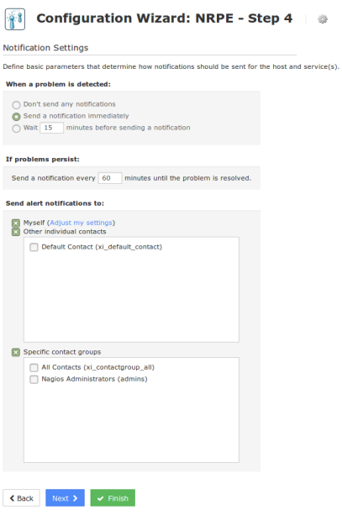

Step 5 provides the group and parent options. These options will be defined in the hostgroups, hostgroup_name, servicegroups and parents directives of the host and service objects that are created by the wizard. After making all of your required selections click the Next button to proceed to the Final Step. On the Final Step you can click Apply to finish the wizard, this will create the monitoring objects. You will notice that from step 3 - 5 there is a Finish button. If you are happy with the default options of the wizard you can click Finish and the wizard will create the monitoring configurations, exactly as if you had clicked the Apply button on the final step.
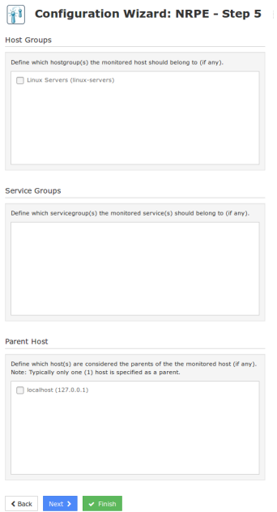
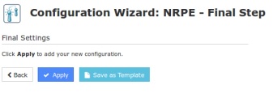
How The Wizard Creates Objects Based on the steps provided in the NRPE wizard that was run in the last section, when applied it will create:
• Host object called centos12.box293.local
• A service object called Ping that is linked to the host object
• A service object called Current Users that is linked to the host object If you navigate to Core Configuration Manager (CCM) you will find these objects and be able to update options as required. In steps 3-5 the options chosen will be applied to both the host and service objects. With options such as contacts and contact_groups, because they are applied on both the host and services, any object inheritance is ignored. Object inheritance is an advanced feature of Nagios Core that allows directives such as contacts and contact_groups to be inherited by the services which can help reduce configuration complexity. However as as soon as a service object has the contacts or contact_groups directives defined, any inheritance from the host is ignored. While on the topic of contacts, it is a recommended best practice to put your users in contact groups and use those groups for notification preferences. The reasoning behind this is that it is easier to change the group membership as apposed to having to update every object when adding or removing a contact.
Running A Wizard For An Already Monitored Server
If you have previously run the monitoring wizard against a server, you can run the monitoring wizard again at a later date to add more services to be monitored. Keep in mind that if you chose to monitor a service that already exists then it will not be overwritten. For example, in the NRPE wizard earlier the Current Users service was selected. When the wizard creates the objects, it will check to see if a service already exists and if it does then it will not attempt to create the service again. More importantly is the name of the host object you provide on Step 2 of the wizard. Looking at the screenshot to the right you can see the wizard has auto populated centos12.box293.local in the Host Name field. This name can be changed to something like CENTOS12 for example.
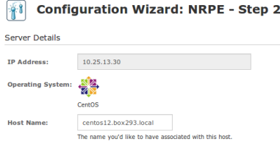
When you are running a wizard to add services to an existing host, the Host Name field MUST match the name of the existing host object and it is CaSe sEnSiTiVe. If you had originally called the host CENTOS12 then you would need to re-type this the same. If you don't, then a new host object will be created and your new services will not be linked to your existing host objects.
Wizard Templates
Wizards Templates allow you to define the Step 3 - 5 options so you can use them whenever running a wizard. This ensures you always apply the same options every time you run a wizard.
Note: Do not confuse wizard templates with the templates that are available in CCM, these are completely separate.
To create a wizard template, after you have stepped through a configuration wizard, on the final step click the Save as Template button. You will be presented with a pop-up window where you can give it a title and description. You can also make it a global template by checking the box. Global templates are templates that all users can use (normally templates are available for the user who created them).
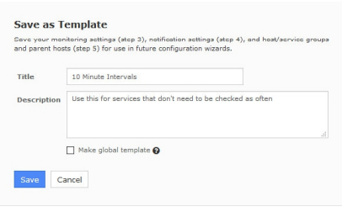
Click the Save button and once the template has been saved you will be returned to the final step of the wizard. To use a template, on any step during the wizard click the gear icon to the right of the wizard title. This will provide a drop down list of wizard templates you can select to be used when running this instance of the wizard. Click the gear icon again to hide the drop down list.
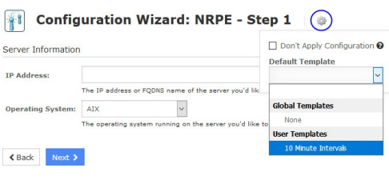
To manage wizard templates navigate to Configure > Configuration Tools > Manage Templates.
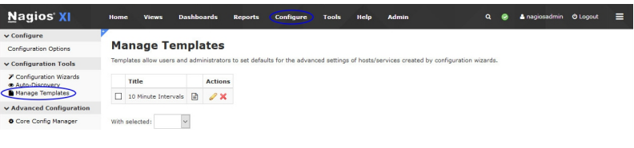
You can use the icons in the action column to edit or delete individual templates. If you wish to delete multiple templates you can select multiple check boxes in the left column and use the With selected drop down list underneath to perform the bulk action. Editing a template allows you to update any of the options in steps 3 - 5

Short for Secure Shell and Secure Sockets Layer, respectively, SSH and SSL share many similarities. For example, they both help create a secure connection on the web. However, there are a handful of differences between the two that are important to understand so you can ensure that you’re using these features properly.
In this post, we’ll introduce you to both SSH and SSL, explaining what each one is and what they’re used for. Then we’ll take a deeper dive to discuss some of the key differences between the two. Let’s get started!
An introduction to SSL
As we mentioned earlier, SSL is short for “Secure Sockets Layer”. It is a security protocol that helps safeguard the protection between web browsers and servers by encrypting the data that is transmitted between the two.
As a WordPress user, you may be at least somewhat familiar with the term from having to install an SSL certificate on your site. SSL is needed in order to enable HTTPS browsing:
It’s important to note that, although many people still refer to it as SSL, this term is technically the outdated version of Transport Layer Security (TLS) protocol. In a nutshell, SSL 2.0 and SSL 3.0 are now obsolete and have been upgraded to TLS 1.2 and 1.3. While there are some differences, they basically function the same way and serve the same purpose. Thus, for this article we’ll refer to it as SSL.
SSL helps encrypt your data while it’s in transit, to prevent malicious actors from intercepting it and executing Man-in-the-Middle (MiTM) attacks. The SSL protocol is applied to servers via SSL certificates.
SSL serves two main purposes: data encryption and authentication. Data encryption protects sensitive information such as credit card information, passwords, and social security numbers. Meanwhile, authentication is used to verify the server and browser identification.
An introduction to SSH
SSH stands for Secure Shell. It is a cryptographic protocol that enables a secure connection to a server. Its purpose is to help protect your site files and data from being compromised when managing them via a remote connection. Basically, it helps to safeguard your server.
Chances are that when you’re accessing your website’s server, it’s done via SSH. This is instead of, for example, accessing the original server located at your hosting provider company. SSH helps ensure that when you’re performing tasks such as adding new files for plugins and themes on your WordPress site, hackers won’t be able intercept the data.
However, you may not necessarily require SSH access. For example, one of the reasons many users opt for managed WordPress hosting is so that they don’t have to handle the technical tasks themselves. However, if you’re more hands-on, you may wish to obtain this level of control. If that’s the case, it’s important to choose a host that offers SSH access, as not all do:

The process of creating an encrypted connection is done via what’s known as SSH tunneling. To create the tunnel, authentication is needed using a set of cryptographic public and private keys, or a username and password.
SSH vs SSL: Understanding the key differences
Now that we understand a little bit more about each of these encryption protocols, let’s take a look at how they differ. Below are three key differences between SSH vs SSL:
They use different ports. SSH works on port 22. SSL works on post 443.
Different forms of authentication are used. SSH has a username and password authentication system, whereas SSL doesn’t. SSL uses digital certificates and public key infrastructure, and authentication only happens on the server-side. Meanwhile, SSH uses a three-step process: server verification, session key generation, and client authentication.
They are used for different types of encryption. SSH is used to encrypt communication happening between two computers or systems online. It enables users to run commands remotely. On the other hand, SSL is used to encrypt communication between browsers and servers – or, in other words, between websites and visitors.
Of course, there are additional differences that distinguish the two. However, the aforementioned three are the most important ones to be aware of.
How to get SSH and SSL for your WordPress site
By now, you likely understand the main points regarding SSH vs SSL. However, you may not be sure how to actually obtain the two for your WordPress site.
Let’s start with SSH. As we mentioned earlier, the easiest way to acquire SSH access is to choose a hosting provider that offers that level of control with its package.
The process for using SSH varies by host. For example, sometimes you have to request for it to be enabled. Other times, it may be offered as a one-click feature.
Conclusion
When you’re managing a WordPress site, it’s essential to ensure that you’re using secure methods to safeguard your data. This includes using encryption and authentication protocols so that your communication is protected from malicious actors. Both SSH and SSL help you do this, but differentiating between the two can be challenging.
As we discussed in this article, there are three key differences between SSH vs SSL:
SSL works on port 443, while SSH works on port 22.
SSH uses a username/password authentication system, while SSL uses a digital certificate.
SSH encrypts remote communication between computers, while SSL establishes a secure connection between servers and browsers.
MRTG, or Multi Router Traffic Grapher, is a free, open-source tool that monitors network traffic and generates visual representations of it:
What it does
MRTG monitors network traffic load on network links using SNMP and generates HTML pages with images that show the traffic.
What it can help with
MRTG can help with analyzing network traffic trends, tracking past traffic patterns, recording system downtime, and more.
What it works on
MRTG is written in Perl and works on Unix/Linux, Windows, and Netware systems

ZABBIX:
Zabbix is an open-source software tool to monitor IT infrastructure such as networks, servers, virtual machines, and cloud services. Zabbix collects and displays basic metrics.
Zabbix is a software that monitors numerous parameters of a network and the health and integrity of servers, virtual machines, applications, services, databases, websites, the cloud and more. Zabbix uses a flexible notification mechanism that allows users to configure email-based alerts for virtually any event.

Category | Nagios Core | Zabbix
Dashboard and User Interface | High-quality dashboard.  The Nagios Core dashboard provides basic information such as the status of devices but it doesn’t offer the same level of clarity and display quality as Zabbix. | High-quality dashboard.  Zabbix has the edge based on its production value. The Zabbix dashboard can be customized and offers a cleaner experience than Nagios Core.
Configuration | Nagios forces the user to enter configurations as text files. | Configuration is another feature that leans heavily towards Zabbix.  Zabbix allows you to change your configurations through a web-based interface.
Visualization | Nagios Core doesn’t offer graphs by default. However, if you download the NagVis plugin then you can monitor your network through the use of graphs. | Zabbix has its own premium graphs available out-of-the-box.
Web Interface | Has its own web-based interface.  Convenient to deploy but your interaction with Nagios Core is quite limited. For example, you can do the basics like view network health and generate reports but you can’t do much more. The user interface is also considerably outdated. | Has its own web-based interface.  Convenient to deploy. Zabbix allows you to configure your monitoring environment through the use of a modern user interface.
Autodiscovery | Includes an autodiscovery feature. With the NagiosQL plugin, you can run autodiscovery to find connected devices. This is one of the few areas where Nagios Core has a distinct advantage over Zabbix. | Includes an autodiscovery feature that can scan for devices by IP range.
Protocol Support | Offers support for HTTP, FTP, SMTP, SNMP, POP3, SSH and MySQL. | Offers support for HTTP, FTP, SMTP, SNMP, POP3, SSH and MySQL.
Alerts and Notifications | Alerts and notifications are offered out-of-the-box.  You can opt to receive Alerts through email and SMS. Nagios Core offers multiple alert levels but it simply doesn’t match Zabbix’s customization. | Alerts and notifications are offered out-of-the-box.  You can opt to receive Alerts through email and SMS. Zabbix also allows You to customize messages and to determine an escalation chain.
Monitoring Templates | No | Zabbix offers templates for FTP, HTTP, HTTPS, IMAP, LDAP, MySQL, NNTP, SMTP, SSH, POP and Telnet. | Zabbix
Plugins | Nagios Core offers an extensive range of additional plugins. | No | Nagios Core
Community | 67,000 members | 80,000 members | Zabbix

OpenNMS is a free and open-source enterprise grade network monitoring and network management platform. It is developed and supported by a community of users and developers and by the OpenNMS Group, offering commercial services, training and support.
The benefits of using a network monitoring solution include improved network performance and reliability, enhanced security, reduced downtime, and increased operational efficiency.
USE OF OPENNMS:
OpenNMS is an open-source network monitoring platform that helps you visualize and monitor everything on your local and distributed networks. OpenNMS offers comprehensive fault, performance, traffic monitoring, and alarm generation in one place.
OPENNMS FILE TYPE:
OpenNMS supports a variety of file types, including:
.xml
Configuration files that can be viewed and edited in the OpenNMS UI using the File Editor
.cfg
Configuration files that can be viewed and edited in the OpenNMS UI using the File Editor
.drl
Configuration files that can be viewed and editing in the OpenNMS UI using the File Editor
OpenNMS also supports a variety of resource types, including:
Persistence selector strategies, Storage strategies, IndexStorageStrategy, JexlIndexStorageStrategy, ObjectNameStorageStrategy, FrameRelayStorageStrategy, HostFileSystemStorageStategy.
Manage Configuration Files in the UI
The File Editor, available in the new UI, lets users view and edit configuration files (.xml, .cfg, .drl, etc.) with the OpenNMS UI instead of having to edit them directly in the file system (for example in the /etc directory).
Making changes to configuration files will affect how OpenNMS operates and incorrectly editing a file could result in features no longer working or not working as intended.
To access the File Editor, go to the new UI, for example by clicking on "UI Preview", then navigating to "File Editor".
View Files
After navigating to the File Editor, the UI displays a tree view of the OpenNMS /etc directory.
From here you can:
navigate to any file
expand and collapse subtrees
search for any part of a file or directory name
view and edit files
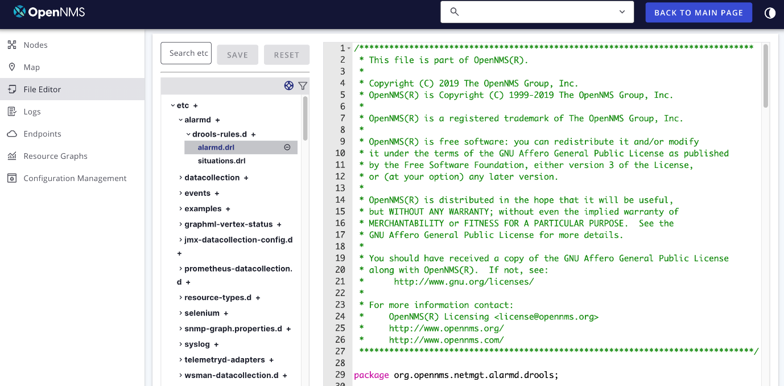
Figure 1. File Editor main screen
Edit Files
To edit a file, type in the file text display.
To save the file, click "Save".
This will overwrite the file on disk; there is no versioning or backup file support at this time.
Click the Reset button to reload the file from disk into the editor. This will be the text as it was last saved to disk, not necessarily the original text before you began editing.
Add Files
To add a new file, navigate to a folder and click the plus + sign.
Enter a file name, add some text, and click Save.
Note that validation will run when you attempt to save the file and may prevent it from being saved. A message at the bottom of the text editor provides more information on why validation failed.
To delete a file, click on the minus sign - to the right of the file name. A confirmation dialog appears. Click Confirm to delete the file or Cancel to cancel the action.
Deleting a file is permanent; the file will be removed from disk and is unrecoverable.
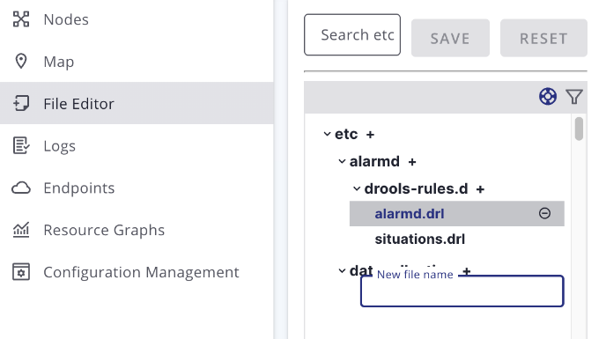
Figure 2. Add a new file
Activate the Changes
Depending on which file was edited, OpenNMS may detect and apply the configuration changes automatically, or else may require a restart.
Some additional information can be found in these topics:
Daemon Configuration Files
Daemon Reference provides an overview of all daemons, their related configuration files, and which ones you can reload without restarting OpenNMS
Console
A console window at the bottom of the edit pane appears with some detailed information after you perform actions such as save or delete. Click Clear to clear the console text or Minimize to minimize the console window.
OPENMS REPORT GENERATION:
Database Reports
Reporting on information from the Horizon monitoring system is important for strategical or operational decisions. Database reports give access to the embedded JasperReports engine and allow users to create and customize report templates. Run these reports on demand or on a predefined schedule within Horizon.
Originally database reports created reports working on data stored in the Horizon database only. This is no longer mandatory, you can also use performance data. Theoretically, the reports do not need to be Horizon related.
The Horizon Report Engine lets you create reports and supports distributed report repositories. This documentation does not cover these features. It describes only reports using JasperReports and Grafana dashboards.
Overview
The Horizon Report Engine uses the JasperReport library to create reports in various output formats. Each report template must be a *.jrxml file. The Horizon Report Engine passes a JDBC connection to the Horizon database to each report on execution.
Table 1. Feature overview
Supported Output Formats | PDF, CSV
JasperReport Version | 6.3.0
For more details on how JasperReports works, please refer to the Jaspersoft Studio official documentation.
Using existing reports
OpenNMS provides the following sample report templates, located in ${OPENNMS_HOME}/etc/report-templates, which you can customize to suit your needs:
Report Name | Category | Description
Availability Summary | Status | Summary of statistics on outages and availability for a user-specified node tag during a user-specified number of days.
Availability by Node | Status | List of availability statistics for each node in a user-specified node tag during a user-specified number of days.
Default Calendar | Status | Same availability information as Default Classic except that the two tables on daily availability are presented as a calendar. This is not a JasperReport.
Default Classic | Status | Availability information of network focusing on last month and current month to date. Information on devices with most problems and monitored services. This is not a JasperReport.
Event Analysis | Status | Tables and charts showing different slices on the top 25 events over the past 30 days.
Grafana Dashboards | Grafana | Create Report from Grafana Dashboard, three options are provided.
Interface Availability | Status | Shows the availability of interfaces with outages within a time range.
Maintenance Contracts Expired | Asset Management | Shows which assets with maintenance contracts are going to expire within a given time range.
Maintenance Contracts Strategy | Asset Management | Provides an overview of assets, showing how many within each age group have an active contract, no contract, or an expired contract. It also shows how many will expire in the next 12 months.
Early Morning Report | Status | Summary of network node status over the past 24 hours.
Response Time Summary | Status | Summary of response times for nodes with a given tag.
Response Time by Node | Status | How long it takes a node to respond, listed by node.
Serial Interface Utilization Summary | Status | Summary of serial interface utilization.
SNMP Interface Availability | Status | Status of SNMP interfaces over time range.
Total Bytes Transferred by Interface | Usage | Bytes transferred by interface.
Average and Peak Traffic Rates for Nodes by Interface | Usage | Average and peak traffic rates for nodes by interface.
Modify existing reports
All default Horizon reports are located in $OPENNMS_HOME/etc/report-templates. Each .jrxml file located there can be modified; the changes are applied the next time Horizon creates a report.
When a subreport has been modified, Horizon will detect a change based on the report’s lastModified time and will recompile the report. A compiled version of the report is represented by a .jasper file with the same name as the .jrxml file. Subreports are located in $OPENNMS_HOME/etc/report-templates/subreports.
If unsure, simply delete all .jasper files and Horizon will automatically compile the subreports if needed.
Add a custom report
To add a new JasperReport report to the local Horizon report repository, do the following:
Create a new entry in the $OPENNMS_HOME/etc/database-reports.xml file.
<report
id="MyReport"
display-name="My Report"
online="true"
report-service="jasperReportService"
description="This is an example description. It shows up in the web ui when creating an online report"
/>
A unique identifier
The name of the report. Appears in the web UI.
Defines if this report can be executed on demand, otherwise only scheduling is possible.
The report service implementation to use. In most cases this is jasperReportService.
A description of the report. Appears in the web UI.
In addition, create a new entry in the $OPENNMS_HOME/etc/jasper-reports.xml file.
<report
id="MyReport"
template="My-Report.jrxml"
engine="jdbc"
/>
The identifier defined in the previous step. This identifier must exist in $OPENNMS_HOME/etc/database-reports.xml.
The name of the template. The template must be located in $OPENNMS_HOME/etc/report-templates.
The engine to use. It is either jdbc or null.
Jaspersoft Studio use
When developing new reports, we recommended using the Jaspersoft Studio application. Download it here.
We recommend to always use the same Jaspersoft Studio version that the Horizon JasperReport library uses. Currently Horizon uses version 6.3.0.
Connect to the Horizon database
To actually create SQL statements against the Horizon database you must create a database Data Adapter. The official Jaspersoft Studio documentation and wiki describe how to do this.
Use Measurements Datasource and Helpers
To use the Measurements API you must add the Measurements Datasource library to the build path of JasperStudio. To do so, right-click in the Project Explorer and select Configure Buildpath.
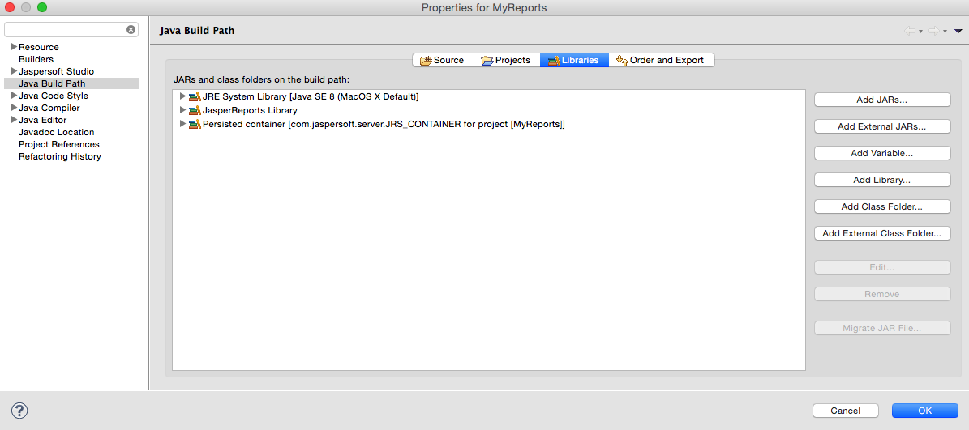
Switch to the Libraries tab.
Click Add External JARs and select the opennms-jasperstudio-extension-{opennms-version}-jar-with-dependencies.jar file located in $OPENNMS_HOME/contrib/jasperstudio-extension.
Close the file selection dialog.
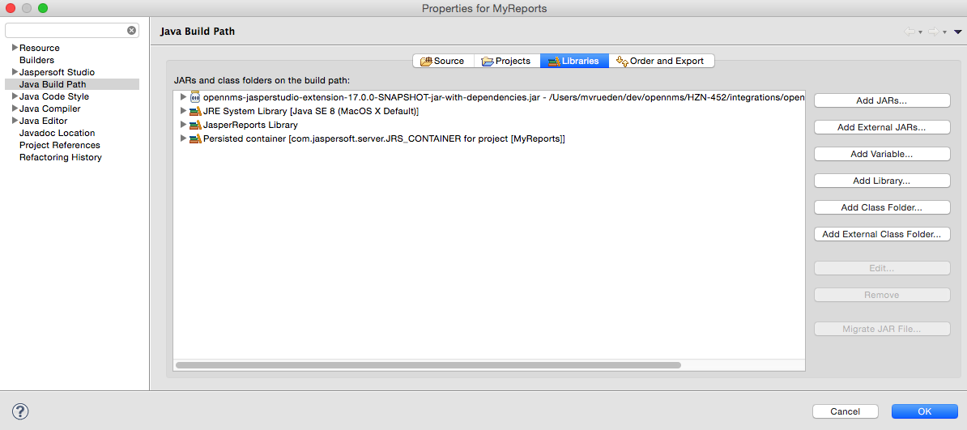
The Measurements Datasource and Helpers should now be available.
Go to the Dataset and Query Dialog in Jaspersoft Studio and select the "measurement" language.
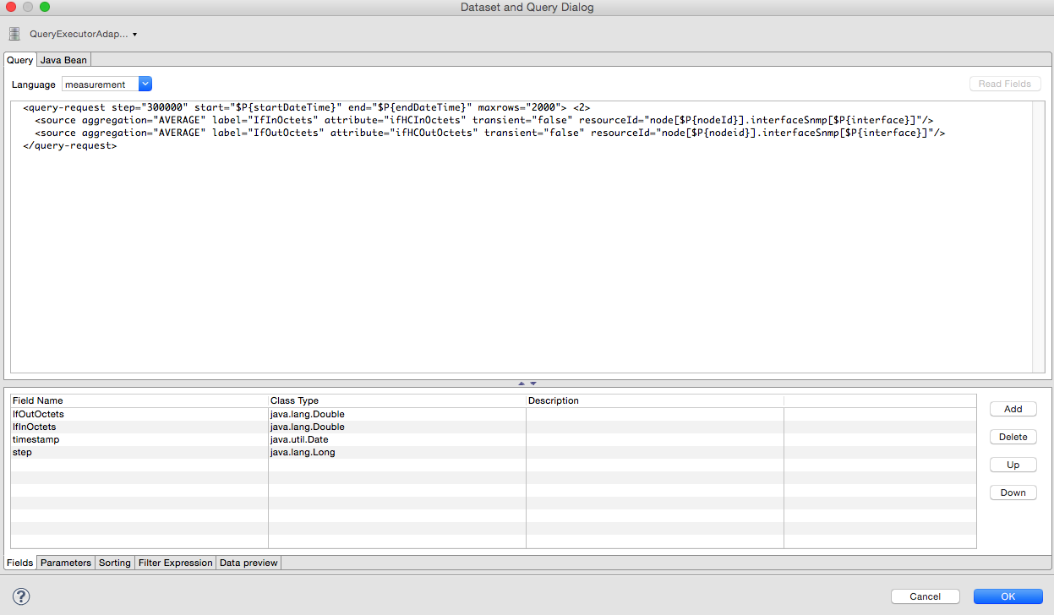
If the Read Fields functionality is not available, use the Data preview. Use the MEASUREMENT_URL, MEASUREMENT_USERNAME, and MEASUREMENT_PASSWORD connection parameters to Access the Measurements API. See Supported Fields for more details.
Accessing performance data
To access performance data within reports, we created a custom Measurement Datasource that lets you query the Measurements API and process the returned data in your reports. Refer to the Measurements API documentation on how to use the Measurements API.
When using the Measurements Datasource within a report, an HTTP connection to the Measurements API is established only if the report is not running within Horizon; for example, when used with Jaspersoft Studio.
To receive data from the Measurements API, create a query as follows:
Sample queryString to receive data from the Measurements API
<query-request step="300000" start="$P{startDateTime}" end="$P{endDateTime}" maxrows="2000">
<source aggregation="AVERAGE" label="IfInOctets" attribute="ifHCInOctets" transient="false" resourceId="node[$P\{nodeid}].interfaceSnmp[$P{interface}]"/>
<source aggregation="AVERAGE" label="IfOutOctets" attribute="ifHCOutOctets" transient="false" resourceId="node[$P\{nodeid}].interfaceSnmp[$P{interface}]"/>
</query-request>
The query language. In our case, "measurement", but JasperReports supports a lot out of the box, such as sql, xpath, and so on.
Fields
Each data source should return a number of fields, which you can use in the report. The Measurement Datasource supports the following fields:
Name | Description | Type
label | Each source defined as transient=false can be used as a field. The name of the field is the label; for example, IfInOctets. | java.lang.Double
timestamp | The timestamp of the sample. | java.util.Date
step | The step size of the response. Returns the same value for all rows. | java.lang.Long
start | The start timestamp in milliseconds of the response. Returns the same value for all rows. | java.lang.Long
end | The end timestamp in milliseconds of the response. Returns the same value for all rows. | java.lang.Long
For more details about the response, see the official Measurement API documentation.
Parameters
In addition to the queryString, the following JasperReports parameters are supported.
Parameter name | Description
Required
MEASUREMENTURL | The URL of the Measurements API; for example, http://localhost:8980/opennms/rest/measurements
Optional
MEASUREMENT_USERNAME | If authentication is required, specify the username; for example, "admin".
MEASUREMENT_PASSWORD | If authentication is required, specify the password; for example, "admin"
Disable scheduler
When you need to disable the scheduler executing the reports, set the system property opennms.report.scheduler.enabled to false. You can set this in a .properties file in the ${OPENNMS_HOME}/etc/opennms.properties.d/ directory.
Helper methods
There are a few helper methods to help create reports in Horizon.
These helpers come with the Measurement Datasource.
Table 2. Supported helper methods for the org.opennms.netmgt.jasper.helper.MeasurementsHelper class
Helper method | Description
getNodeOrNodeSourceDescriptor(nodeId, foreignSource, foreignId) | Generates a node source descriptor according to the input parameters. Either node[nodeId] or nodeSource[foreignSource:foreignId] is returned.  nodeSource[foreignSource:foreignId] is returned only if foreignSource and foreignId are not empty and not null. Otherwise, node[nodeId] is returned.  nodeId: String, the ID of the node.  foreignSource: String, the foreign source of the node. May be null.  foreignId: String, the foreign ID of the node. May be null.  For more details, see Node source descriptor use.
getInterfaceDescriptor(snmpifname, snmpifdescr, snmpphysaddr) | Returns the interface descriptor of a given interface; for example, en0-005e607e9e00. The input parameters are prioritized.  If an snmpifdescr is specified, it is used instead of the snmpifname.  If an snmpphysaddr is defined, it will be appended to snmpifname/snmpifdescr.  snmpifname: String, the interface name of the interface; for example, en0. May be null.  snmpifdescr: String, the description of the interface; for example, en0. May be null.  snmpphysaddr: String, the MAC address of the interface; for example, 005e607e9e00. May be null. As each input parameter may be null, not all of them can be null at the same time. At least one input parameter has to be defined.  For more details, see Interface descriptor use.
Node source descriptor use
A node is addressed by a node source descriptor. The node source descriptor references the node either via the foreign source and foreign ID or by the node ID.
If storeByForeignSource is enabled, it is only possible to address the node via foreign source and foreign ID.
To make report creation easier, there is a helper method to create the node source descriptor.
For more information, see Storing data with foreign sources on Discourse.
The following example shows the use of that helper.
jrxml report snippet to visualize the use of the node source descriptor.
<parameter name="nodeResourceDescriptor" class="java.lang.String" isForPrompting="false">
<defaultValueExpression><![CDATA[org.opennms.netmgt.jasper.helper.MeasurementsHelper.getNodeOrNodeSourceDescriptor(String.valueOf($P{nodeid}), $Pforeignsource, $P{foreignid})]]></defaultValueExpression>
</parameter>
<queryString language="Measurement">
<![CDATA[<query-request step="300000" start="$P{startDateTime}" end="$P{endDateTime}" maxrows="2000">
<source aggregation="AVERAGE" label="IfInOctets" attribute="ifHCInOctets" transient="false" resourceId="$P{nodeResourceDescriptor}.interfaceSnmp[en0-005e607e9e00]"/>
<source aggregation="AVERAGE" label="IfOutOctets" attribute="ifHCOutOctets" transient="false" resourceId="$P{nodeResourceDescriptor}.interfaceSnmp[en0-005e607e9e00]"/>
</query-request>]]>
Depending on the input parameters, you get either a node resource descriptor or a foreign source/foreign ID resource descriptor.
Interface descriptor use
An interface Snmp is addressed with the exact interface descriptor. To allow easy access to the interface descriptor, we provide a helper tool. The following example shows the use of that helper.
jrxml report snippet to visualize the use of the interface descriptor
<parameter name="interface" class="java.lang.String" isForPrompting="false">
<parameterDescription><![CDATA[]]></parameterDescription>
<defaultValueExpression><![CDATA[org.opennms.netmgt.jasper.helper.MeasurementsHelper.getInterfaceDescriptor($P{snmpifname}, $P{snmpifdescr}, $P{snmpphysaddr})]]></defaultValueExpression>
</parameter>
<queryString language="Measurement">
<![CDATA[<query-request step="300000" start="$P{startDateTime}" end="$P{endDateTime}" maxrows="2000">
<source aggregation="AVERAGE" label="IfInOctets" attribute="ifHCInOctets" transient="false" resourceId="node[$P{nodeid}].interfaceSnmp[$P{interface}]"/>
<source aggregation="AVERAGE" label="IfOutOctets" attribute="ifHCOutOctets" transient="false" resourceId="node[$P{nodeid}].interfaceSnmp[$P{interface}]"/>
</query-request>]]>
To get the appropriate interface descriptor depends on the input parameter.
HTTPS use
To establish a secure connection to the Measurements API, you must import the public certificate of the running Horizon to the Java Truststore. In addition, you must configure Horizon to use that Java Truststore. Please follow the instructions in this section to set up the Java Truststore correctly.
In addition, set the property org.opennms.netmgt.jasper.measurement.ssl.enable in $OPENNMS_HOME\etc\opennms.properties to "true" to ensure that only secure connections are established.
If org.opennms.netmgt.jasper.measurement.ssl.enable is set to "false", an accidentally insecure connection can be established to the Measurements API location. An SSL-secured connection can be established even if org.opennms.netmgt.jasper.measurement.ssl.enable is set to "false".

Report Templates
The last two parameters for most reports are checkboxes for delivery and scheduling of the report. Checking the "Deliver this report" checkbox will provide the delivery options described below. Checking the "Schedule this report" checkbox will open up the scheduling editor, which is described in the Schedule Editor section below.
Report Delivery Options
Specify the following report delivery options:
Unique name (must be unique among all scheduled reports)
Format (PDF, CSV)
Delivery options
Save a copy of the report (view in the Persisted Reports tab)
Email report (use a comma to separate multiple email addresses)
Webhook (posts generated report to specified HTTP endpoint)
Schedule Editor
Specify the schedule for automatic report delivery:
Daily
Days per week (specific day(s) of the week)
Days per month (specific day(s) of the month, for example, third Sunday of the month)
Cron expression
Each schedule has additional fields associated with it, such as days of the week, interval, and specific time.
Once you set that information, click Deliver Report to generate the report and save, email, or webhook the report as specified in the Report Delivery Options section of the screen.
Note that a list of scheduled reports appears in the Report Schedules tab.
Events
Events are structured historical records of things that happen in Horizon and the nodes, interfaces, and services it monitors. Events are central to the operation of the Horizon platform, so it’s critical to have a firm grasp of this topic. Whenever something in Horizon appears to work by magic, it’s probably events working in the background.
Events may originate within Horizon itself, or from an external source via SNMP traps, syslog messages, or a variety of other sources. Event definition files are used to provide a standard framework for eventd to process events evenly, regardless of how they were sent to the server.
The event bus
At the heart of Horizon lies an event bus. Any Horizon component can publish events to the bus, and any component can subscribe to receive events of interest that have been published on the bus. This publish-subscribe model enables components to use events as a mechanism to send messages to each other.
For example, the Horizon provisioning subsystem publishes a node-added event whenever a new node is added to the system. Other subsystems with an interest in new nodes subscribe to the node-added event and automatically receive these events, so they know to start monitoring and managing the new node if their configuration dictates. The publisher and subscriber components do not need to have any knowledge of each other, allowing for a clean division of labor and lessening the programming burden to add entirely new subsystems or modify the behavior of existing ones.
Event Daemon Configuration
The back-end configuration surrounding events is split into two areas: the configuration of eventd itself, and the configuration of events definitions known to Horizon.
The eventd-configuration.xml file
The overall behavior of eventd is configured in the ${OPENNMS_HOME}/etc/eventd-configuration.xml file. This file does not need to be changed in most installations. The configurable items include the following:
TCPAddress
The IP address to which the eventd XML/TCP listener will bind. Defaults to 127.0.0.1.
TCPPort
The TCP port number on TCPAddress to which the eventd XML/TCP listener will bind. Defaults to 5817.
UDPAddress
The IP address to which the eventd XML/UDP listener will bind. Defaults to 127.0.0.1.
UDPPort
The UDP port number on TCPAddress to which the eventd XML/UDP listener will bind. Defaults to 5817.
receivers
The number of threads allocated to service the event intake work done by eventd.
queueLength
The maximum number of events that may be queued for processing. Additional events will be dropped. Defaults to unlimited.
getNextEventID
An SQL query statement used to retrieve the ID of the next new event. Changing this setting is not recommended.
socketSoTimeoutRequired
Whether to set a timeout value on the eventd receiver socket.
socketSoTimeoutPeriod
The socket timeout, in milliseconds, to set if socketSoTimeoutRequired is set to yes.
logEventSummaries
Whether to log a simple (terse) summary of every event at level INFO. Useful when troubleshooting event processing on busy systems where DEBUG logging is not practical.
The set of known events is configured in ${OPENNMS_HOME}/etc/eventconf.xml. This file opens with a <global> element, whose <security> child element defines which event fields may not be overridden in the body of an event submitted via any eventd listener. This mechanism stops a malicious actor from, for instance, sending an event whose operator-action field amounts to a phishing attack.
After the <global> element, this file consists of a series of <event-file> elements. The content of each <event-file> element specifies the path of a tributary file whose contents will be read and incorporated into the event configuration. These paths are resolved relative to the ${OPENNMS_HOME}/etc directory; absolute paths are not allowed.
Each tributary file contains a top-level <events> element with one or more <event> child elements. Consider the following event definition:
<event>
<uei>uei.opennms.org/nodes/nodeLostService</uei>
<event-label>OpenNMS-defined node event: nodeLostService</event-label>
<descr>&lt;p>A %service% outage was identified on interface
%interface% because of the following condition: %parm[eventReason]%.&lt;/p> &lt;p>
A new outage record has been created and service-level
availability calculations will be impacted until this outage is
resolved.&lt;/p></descr>
<logmsg dest="logndisplay">
%service% outage identified on interface %interface%.
</logmsg>
<severity>Minor</severity>
<alarm-data reduction-key="%uei%:%dpname%:%nodeid%:%interface%:%service%" alarm-type="1" auto-clean="false"/>
</event>
Every event definition has this same basic structure. See Anatomy of an event for a discussion of the structural elements.
A word about severities
When setting event severities, it’s important to consider each event in the context of your infrastructure as a whole. Events whose severity is critical at the zoomed-in level of a single device may not merit a Critical severity in the zoomed-out view of your entire enterprise. Since an event with Critical severity can never have its alarms escalated, you should usually reserve this highest severity level for events that unequivocally indicate a truly critical impact to the business. Rock legend Nigel Tufnel offered some wisdom on the subject.
Structure of the eventconf.xml tributary files
The order of event definitions is very important, as an incoming event is matched against them in order. It is possible, and often useful, to have several event definitions that could match variant forms of a given event; for example, based on the values of SNMP trap variable bindings.
The tributary files included via the <event-file> tag have been broken up by vendor. When Horizon starts, each tributary file is loaded in order. The ordering of events inside each tributary file is also preserved.
The tributary files listed at the end of eventconf.xml contain catch-all event definitions. When slotting your own event definitions, take care not to place them below these catch-all files; otherwise your definitions will be effectively unreachable.
A Few Tips
To save memory and shorten startup times, you may want to remove event definition files that you know you do not need.
If you need to customize some events in one of the default tributary files, you may want to make a copy of the file containing only the customized events and load the copy above the original in eventconf.xml. This practice will make it easier to maintain your customizations in case the default file changes in a future release of Horizon.
Event Definition
Associate an event to a specific node
There are two ways to associate a given event to an existing node, prior to sending the event to the event bus:
Set the event’s nodeId to the database ID of the desired node.
For requisitioned nodes, set the _foreignSource and _foreignId as parameters to the event. In this case, any incoming event without a nodeId and these two parameters will trigger a database lookup. If a node is found, the nodeId attribute will be dynamically set on the event, regardless of which method has been used to send it to the event bus.
Anatomy of an event
Events are structured historical records of things that happen in Horizon and the nodes, interfaces, and services it monitors. Every event has a number of fixed fields and zero or more parameters.
Mandatory fields
UEI (Unique Event Identifier)
A String that uniquely identifies the event’s type. UEIs are typically formatted in the style of a URI, but the only requirement is that they start with uei..
Event Label
A short, static label that summarizes the gist of all instances of this event.
Description
A long-form description of all instances of this event. You can use HTML formatting to format the body of the event text.
Log Message
A long-form log message describing this event, optionally including expansions of fields and parameters so that the value is tailored to the event at hand. The possible options for this setting are the following:
logndisplay
Both log the event in the database and display it in the Web UI.
logonly
Log the event in the database, but do not display it.
suppress
Neither log the event in the database nor display it.
donotpersist
Do not log the event in the database, but still send it to daemons that are listening for this type of event, such as those being used to generate notifications. Note that eventd and alarmd don’t process this type of events.
discardtraps
This applies only to traps coming in via trapd. This will cause trapd to discard the trap without creating an event. Other daemons that are listening for this type of event will not receive this event.
Severity
A severity for this event type. Possible values range from Cleared to Critical. Refer to our notes on severities for tips on how to best set the event levels.
Event ID
A numeric identifier used to look up a specific event in the Horizon system.
Notable optional fields
Operator Instruction
A set of instructions for an operator to respond appropriately to an event of this type.
Alarm Data
If this field is provided for an event, Horizon will create, update, or clear alarms for events of that type according to the alarm-data specifics.
(OPENNMS- FILETYPE, CONFIGURATION FILE, REPORT GENERATION, OPENNMS EVENT, HOW TO ADD USER, NOTICES IN OPENNMS) TO KNOW DETAIL ABOUT THE OPNNMS VISIT:
https://docs.opennms.com/horizon/30/operation/events/event-translator.html

OpenNMS has probably one of the fastest SNMP data collection engines on the
planet. However, persisting that data to RRD storage places a tremendous
demand on the system IO due mainly to the way that OpenNMS writes each data
points to its own RRD file. This milestone, provides a more flexible and
configurable way to persist RRD data (group collected data into a single file). This
frees up IO overhead and will improve performance tremendously.
When this feature is enabled, all data points specified in the data collection
configuration file <group> element are stored in a file using the name of the
group. For example, all of the data points below will be stored in a single file for
"mib2-interfaces":

This feature is available in OpenNMS release 1.3.2 and all later releases. It works
with both JRobin and RRD storage strategies.

RRDTool Configuration
RRD (round robin database) parameters for storing and rolling up the collected data samples. RRDTool is a product that grew out of MRTG 1. It creates a very compact database structure for the storage of
periodic data, such as is gathered by OpenNMS. RRD data is stored in files that are created when
initialized to hold data for a certain amount of time. This means that with the first data collection these
files are as large as they will ever get, but it also means that you will see an initially large decrease in disk
space as collection is first started... Once the RRD file is full, the oldest data is discarded.

OpenNMS releases up to and including 1.2.9 used RRDTool proper by default via a JNI 1, meaning that
the resulting files could be read by other applications capable of consuming RRDTool’s file format. The
files written by OpenNMS via the JNI 1 RRD strategy have a .rrd extension by default. Beginning with the
1.3.2 release, the default is to use JRobin 2, a pure-Java implementation of RRDTool 1.0’s functionality.
The files produced via the JRobin RRD strategy have a .jrb extension by default, and are not compatible
with RRDTool proper. See the JRobin site for the motivation behind this decision.

Configuration Details
The default RRD configuration in OpenNMS:

The first line, the rrd step size, determines the granularity of the data. By default this is set to 300
seconds, or five minutes, which means that the data will be saved once every five minutes per step.
Note that this is also one of the few places where time in OpenNMS is referenced in seconds instead of
milliseconds.

Each RRD is made up of Round-Robin Archives. An RRA consists of a certain number of steps. All of the
data that is collected in those steps is then consolidated into a single value that is then stored in the
RRD. For instance, if I poll a certain SNMP variable once a minute, I could have an RRA that would collect
all samples over a step of five minutes, average the (five) values together, and store the average in the
RRD.

The RRA statements take the form:

RRA:Cf:xff:steps:rows

RRA

This string defines the line as an RRA configuration command. It does not change, and is always the text
“RRA”.
Cf
This field represents the “consolidation function”. It can take one of four values, AVERAGE, MAX, MIN,
or LAST. They are detailed below.
xff
This is the “x-files factor”. If we are trying to consolidate a number of samples into one, there is a chance
that there could be gaps where a value wasn’t collected (the device was down, etc.). In that case, the
value would be UNKNOWN. This factor determines how many of the samples can be UNKNOWN for the
consolidated sample is considered UNKNOWN. By default this is set to 0.5 or 50%.
steps
This states the number of “steps” that make up the RRA. For example, if the step size is 300 seconds (5
minutes) and the number of steps is 12, then the RRA is 12 x 5 minutes = 60 minutes = 1 hour long, and
it will stored the consolidated value for that hour.
rows
The rows field determine the number of values that will be stored in the RRA.
Consolidation Functions
These are used in the Cf part of an RRA statement.

AVERAGE
Average all the values over the number of steps in the RRA.
MAX
Store the maximum value collected over the number of steps in the RRA.
MIN
Store the minimum value collected over the number of steps in the RRA.
LAST
Store the last value collected over the number of steps in the RRA.
Let’s bring this all together with some more examples. Take the first RRA line in the configuration:

RRA:AVERAGE:0.5:1:8928

This says to create an archive consisting of the AVERAGE value collected over 1 step and store up to
8928 of them. If, for any step, more than 50% of the values are UNKNOWN, then the average value will
be UNKNOWN. Since the default step size is 300 seconds, or five minutes, and the default polling cycle
(in the collectd configuration) is five minutes, we would expect there to be one value per step, and so
the AVERAGE should be the same as the MIN or MAX or LAST. 8928 five minute samples at 12 samples
per hour and 24 hours per day is 31 days. Thus this RRA will hold five minute samples for 31 days before
discarding data.

The next lines get a little more interesting:

The only difference between these lines is the consolidation function. We are going to “roll up” the step
1 samples (5 minutes) into 12 step samples (1 hour). We are also going to store three values: the
average of all samples during the hour, the minimum value of those samples and the maximum value.
This data is useful for various reports (the AVERAGE shows throughput whereas MAX and MIN show
peaks and valleys). These will be stored as one hour samples 8784 times, or 366 days.

So, to summarize, by default the SNMP collector will poll once every five minutes. This value will be
stored as collected for 31 days. Also, hourly samples will be stored which include the MIN, MAX and
AVERAGE.

You can easily change these numbers to increase or decrease the amount of data stored. A few caveats.
First, increasing the amount and/or frequency of samples will have a direct affect on the amount of disk
space required. You could add a MIN and MAX RRA for the single step RRA, which would increase
necessary disk space by up to 50%, but since by default there is only one value, MIN, MAX and AVERAGE
will be the same, so it is not really necessary unless you also increase the polling rate. Second, you
cannot change these numbers once collection has started without losing all of the collected data up to
that point. So it is important to set your values early. When you change these numbers, you must delete
all .jrb/.rrd files in order for them to be re-created.

Hint
A note for international users. If your LOCALE is set to something other than en_US you may need to use
a comma instead of a period in the xff, for example:

RRA:AVERAGE:0,5:12:8784
RRA:MIN:0,5:12:8784
RRA:MAX:0,5:12:8784
You have to do this if you see a “can’t parse argument RRA:AVERAGE:0.5:1:8928” in the collectd log file.

The main limiting factor for OpenNMS when using RRD files is disk IO. The more data you collect, the
more RRD files you have, the higher the disk IO. But at what point do you need to think about
upgrading?

How about we count the number of RRD files on our monitoring host and then we can graph those over
time along side the disk IO, CPU and memory giving us a good indication when we fall off the cliff of
where the cliff is and when we should worry about it. It's not very helpful in advance of an issue, but it
may well give you enough information to anticipate an issue before it causes a loss of service.

Cacti is an open source, web-based network monitoring, and graphing tool that is designed as a front-end application to the data logging tool that is called as RRDTool.
Cacti
Cacti supports various data collection methods, including Simple Network Management Protocol (SNMP). Cacti monitors the performance and usage of network devices. Data input methods allow Cacti to retrieve performance data to insert into data sources and this data is rendered on various ready-to-use dashboards that Network Performance Insight offers.
It stores all the necessary information to create graphs and populate them with data in database. RRDTool is a round-robin database tool that stores data in a circular buffer-based database. It keeps the system storage footprint constant over the time.
Cacti supports SNMP and IP SLA performance data. SNMP enabled devices can be configured to probe and measure the performance of a network with performance data such as response time, latency, jitter, and packet loss.
Cacti operation is divided into the following three different tasks:
Cacti data sources
Data sources are created to enable Cacti to know how and where the data is stored. Data sources correspond to actual data on the graph.
Round robin archive (RRA) settings can be customized giving the ability to gather data on non-standard time spans while it stores different amounts of data.
Cacti data gathering
Cacti data gathering is done by retrieving data by using a built-in SNMP support or defined scripts with an index to capture the data. Cacti run the scripts, retrieve SNMP data, and update the RRD files in Cacti database.
Cacti templates
In Cacti, a data template provides a skeleton for an actual data source. Cacti can scale to many data sources and graphs by using templates. With the basic Cacti installation, it comes with three different types of templates: Data, Graph, and Host templates.
- Graph templates enable common graphs to be grouped by templating.
- Data source templates enable common data source types to be grouped by templating.
- Host templates are a group of graph and data source templates to define common host types. Host templates define the capabilities of a host. Cacti can then poll for information after any addition of a new host.

Cacti Collector Service
Cacti polls data at predetermined intervals and used the resulting data for visualization purpose. It is generally used to graph time-series performance data, such as to monitor network traffic by polling a network switch or router interface by using SNMP or with defined scripts. Cacti Collector Service collects network performance poll data and provides network monitoring for specific quality of service measurements.
Cacti Collector Service periodically polls the SNMP enabled devices that are stored in Cacti database and perform reconciliation for inventory data.
Cacti Collector Service also gets the performance data from network devices through SSH File Transfer Protocol (or SFTP) by using Reflector plug-in. Reflector plug-in is the custom plug-in that mirrors the performance data from the devices in your network to Reflector log files.
Currently, UNIX getent hosts network administration command line is used to resolve the host names in Cacti Collector. Make sure that you have installed the getent and is able to query the Domain Name System.

Load balancing
The Cacti Collector Service is enabled with an in-built load-balancing mechanism and fail-over capability.

